Statistical Inference - course project part 1

Sangwon Han

2018-12-18

# Overview

In this project, i will investigate the exponential distribution in R and compare it with the Central Limit Theorem. The exponential distribution can be simulated in R with rexp(n, lambda) where lambda is the rate parameter. The mean of exponential distribution is 1/lambda and the standard deviation is also 1/lambda.

The followings are the instruction for this projecct:

1. lambda = 0.2 for all of the simulations.
2. Investigate the distribution of averages of 40 exponentials
3. Need to do a thousand simulations.

# Simulations

Set the conditions

lambda <- 0.2  
n <- 40  
sims <- 1000

Set seed for the reproducibility, and simulate exponential distribution

set.seed(1)  
sim_exp <- replicate(sims, rexp(n, lambda))  
dim(sim_exp)

## [1] 40 1000

Calculate the mean

mean_exp <- apply(sim_exp, 2, mean)

# 1. Sample Mean versus Theoretical Mean

Plot histogram of the means of the exponential distribution.

hist(mean_exp, main = "Distribution of sample mean", xlab = "mean",   
 xlim = c(2, 9), breaks = 30, col = "grey")  
abline(v = mean(mean_exp), lwd = "3", col = "blue")

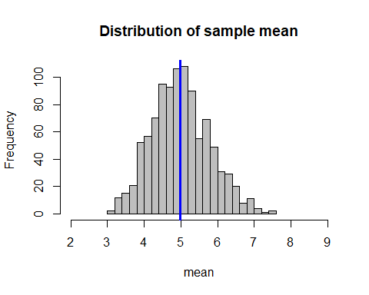

The sample mean is as follow:

mean(mean_exp)

## [1] 4.990025

The theoretical mean of exponential distribution is 1/lambda.

theo_mean <- 1/lambda  
theo_mean

## [1] 5

# 2. Sample Variance versus Theoretical Variance

The sample variance is as follow:

var(mean_exp)

## [1] 0.6111165

The theoretical variance of exponential distribution is ((1/lambda)/sqrt(n))^2.

theo_var <- ((1/lambda)/sqrt(n))^2  
theo_var

## [1] 0.625

# Distribution

The exponential distribution of 1000 simulations is approximately normal. Due to the Central Limit Theorem, the means of the sample simulations should follow a normal distribution.

hist(mean_exp, main = "Distribution of sample mean", xlab = "mean",   
 xlim = c(2, 9), breaks = 30, col = "grey", probability = TRUE)  
  
# add density plot  
lines(density(mean_exp), lwd = 3, col = "red")  
  
# add normal distribution line  
x <- seq(min(mean_exp), max(mean_exp), length = 2 * n)  
y <- dnorm(x, mean = 1/lambda, sd = sqrt(((1/lambda)/sqrt(n))^2))  
lines(x, y, col = "black", lwd = 3, lty = 2)

